UDC: 595.789(540.41Ranchi)(083.82)

Butterflies from the St. Xavier’s College (Ranchi) campus: A Checklist
  - सेंट जेवियर कॉलेज (रांची) परिसर की तितलियाँ: एक सूची
  - Osga J., Kumar M., Mahto D., Minz P.A., Herenj S., Kunkal R. L., Mahto S., Khan M., Pratap R., Ranjan R., Raipat B. S.
Department of Zoology, St. Xavier’s College, Ranchi – 834001, Jharkhand, India.
*johnosgasj@gmail.com

Received: mm/dd/yyyy
Accepted: mm/dd/yyyy
Published: mm/dd/yyyy

Citation: Osga J, Kumar M, Mahto D, Minz PA, Herenj S, Kunkal RL, Mahto S, Khan M, Pratap R, Ranjan R, Raipat BS. 2025. Butterflies from the St. Xavier’s College (Ranchi) campus: A checklist. Vat-Vriksha, 1(1): OM: 06.

सारांश
आर्थ्रोपोड संघ के सबसे सुंदर कीटों में तितलियाँ प्रमुख हैं। ये अपने चमकीले रंगों वाले पंखों के लिए जानी जाती हैं, जो वैज्ञानिकों और शौकिया प्रकृति प्रेमियों दोनों को आकर्षित करते हैं। तितलियाँ परागण की एक अत्यंत महत्वपूर्ण प्रक्रिया में भाग लेती हैं, जब वे रंग-बिरंगे फूलों पर जाकर मधुरस (नेक्टर) का सेवन करती हैं। इस दौरान उनके शरीर पर परागकण चिपक जाते हैं और वे इन्हें अन्य फूलों तक पहुंचाती हैं। अनेक अध्ययनों से यह ज्ञात हुआ है कि विश्वभर में तितलियों की संख्या में तीव्र गिरावट हो रही है, जिससे परागण जैसी आवश्यक पारिस्थितिक सेवा संकट में पड़ गई है023 के छह महीनों की अवधि में किए गए इस अध्ययन के दौरान पाँच परिवारों की 18 तितली प्रजातियों की पहचान की गई।
कुंजी : तितली, सूची, विविधता, रांची, रोपालोसेरा

Abstract
Among the arthropod phylum's most beautiful insects are butterflies. They are well-known for having vividly colored wings that have drawn interest from scientists and amateurs alike. Butterflies participate in the vital process of pollination when they visit vibrant flowers and nectar-feed. In doing so, their bodies gather pollen grains and transport them to other blooms. Numerous studies have revealed a sharp fall in butterfly populations worldwide, putting at risk pollination—an essential ecological service that butterflies provide. Finding them and preserving them is urgently needed right now. In response to these concerns, the current project was started with the goal of creating a checklist of butterflies (Order: Lepidoptera, Suporder: Rhopalocera) on the campus of St. Xavier's College in Ranchi. The center of Ranchi city is where the college campus is situated. Despite being in the middle of a city, the college campus is covered in artificial and natural greenery that is lush and green and draws butterflies. The review of the literature reveals that no prior verified report of any study on butterflies on college campuses exists. During a 6-month period, from August 2022 to February 2023, 18 butterfly species from 5 families were identified in the current study.
.
Keywords: butterfly, checklist, diversity, Ranchi, Rhopalocera.

1. Introduction
One of the most important material bases for human survival and development and ecosystem sustainability is biodiversity (Ren et al., 2022). However, an increased and unplanned anthropogenic activities, to greater extent, had led to loss of biodiversity. In recent years protection and conservation of biodiversity has significantly attracted workers from both local as well as international community (Prudic et al., 2022). This marks the importance of studies on species diversity, which are important for understanding the effects of human development on the reliability and sustenance of an ecosystem (Virani and Madavi, 2021). Butterflies (Suborder Rhopalocera; Order Lepidoptera) are one of the most known and most attractive insects among nature lovers (Dey et al., 2017). Their fascinating diversity of forms and colours have attracted zoologists, especially entomologists throughout the world since time immemorial (Hembrom and Sinha, 2012). In addition to being important pollinators, butterflies also operate as environmental variables since They are extremely susceptible to environmental changes. Different species of butterfly respond differently to the said and other environmental factors (Rosin et al., 2012). Adult butterflies consume nectar, whereas caterpillars rely on host plants (mainly specialised) for leaves (Nimbalkar et al., 2011). To preserve high variety, butterfly communities must be conserved using reasonable and complicated management practices.
There is no historical data on butterflies from the SXCRAN campus. Morrison-Godfrey (1950) reported 121 species during their research in the Hazaribagh and Ranchi regions of Jharkhand. Verma (2009) recorded 39 species from the Dalma Wildlife Sanctuary in Jamshedpur, Jharkhand. Parta et al. (2022) conducted a preliminary investigation in the mountainous terrains of Ghatshilla (Jharkhand) and discovered 72 butterfly species belonging to six families and 55 genera. Kumari and Thakur (2022) recorded 21 species in their study located in Kanke, Ranchi (Jharkhand). Chandra et al. (2007) created a checklist of 174 butterfly species from the neighbouring states of Madhya Pradesh and Chattisgarh in India.
The current study was conducted to assess and quantify butterfly diversity in the St. Xavier's College, Ranchi campus (Lat 23.36700434185223, Long 85.32801267725753) in light of the crucial ecosystem services that butterflies provide and to support their conservation and management. Established in 1944, St. Xavier's College, Ranchi is a religiously-based minority educational college run by the Ranchi Jesuit Province of the Society of Jesus. The college is headquartered in the center of the Ranchi City. There are verdant areas throughout the college campus that include grounds, gardens, trees, and arable land. The college campus is labelled Micro Diversity Zone 1, Micro Diversity Zone 2, and Micro Crops Zone, and these zones are separated from one another. In addition, it has two tiny ponds, which increases the richness of the habitat.

2. Materials and Methods
Collection of butterflies in the St. Xavier’s College, Ranchi (SXCRAN) campus was performed for three months from August 2022 to November 2022. Insect collection net was employed for collection of samples. One individual of each species was preserved for reference and rest were released after counting (Kumar et al., 2022). Photographic records of the insects were obtained using Nikon Coolpix B600 point & Shoot camera (4.3 – 258 mm, 1:3.3 – 6.5). Killing bottles were prepared with plaster of paris as absorbent for ethyl acetate. To preserve the samples, the gathered butterflies were killed with the aforementioned bottle. The samples were next spread and pinned using previously stated standards. (Kumar et al., 2022). The butterflies were identified using butterfly-identification keys (Perveen and Haroon, 2016; Perveen and Fazal (2013); Mohapatra et al., 2012; Stokes and Stokes, 2001)

3. Results
A total of 18 butterfly species were observed during the study (Table 1). The photographs of the observed butterflies have been presented as Figure 1, Figure 2, and Figure 3.
.

4. Discussion
A Forsayeth (1884), Swinhoe (1886), Bentham (1891), and Witt (1909) were among the first to investigate butterfly diversity in central India. In this investigation, 18 species were identified from 5 families and 14 genera. The Nymphalidae family contains the most butterfly species, with nine species and eight genera. Papilionoidea consists of two genera and three species. Pieridae is made up of three species from two genera, while Hesperiidae has two species from two genera. In contrast, the least number of species were recorded in Hesperioidea, with only one species from one genus. The seasonal occurrence of butterflies was determined to be 11% in winter, 21% in autumn, and 68% in summer. This conclusion implies that diversity is more in the summer than in the spring and less in the winter.
Numerous studies have proven Nymphalidae’s dominance in tropical regions. This is due to their polyphagous nature, which allows them to live in a wide variety of settings. Their supremacy stems from their active flying behaviour and ability to hunt a wide range of resources (Forsayeth, 1884). Kumari and Thakur (2022) recorded 21 species in their study located in Kanke, Ranchi (Jharkhand). Chandra et al. (2007) created a checklist of 174 butterfly species from the neighbouring states of Madhya Pradesh and Chhattisgarh in India.
The current study is the first attempt to examine and document butterfly variety at the St. Xavier's College Ranchi Campus, located in the heart of Ranchi city. In the current study, 19 butterfly species from 5 families were identified throughout a 6-month period from August 2022 to February 2023. Because the work is limited to only six months, the butterfly's presence is seasonal. They also reveal some differences between the dry and wet seasons. The current study demonstrates that the studied region provides optimal ecological conditions and habitat for butterflies to survive.

5. Acknowledgements
The authors appreciate the assistance and laboratory support provided by the Head, P.G. Department of Zoology, St. Xavier's College, Ranchi. The authors also want to thank The Principal and Vice Principal of St. Xavier's College in Ranchi for their ongoing encouragement and support.

References
- Ren J, Li S, He M, Z Y. Butterfly community diversity in Qinling mountains. Diversity. 2022;14(1): 27.
- Prudic KL, Cruz TMP, Winzer JIB, Oliver JC, Melkonoff NA, Verbais H, Hogan A. Botanical gardens are local hotspots for urban butterflies in Arid Environments. Insects 2022;13(10): 865.
- Virani RS, Madavi BK. Butterfly diversity of Isapur Wildlife Sanctuary, Maharashtra, India. Vidyabharati International Interdisciplinary Research Journal, 2021;13(1): 754 – 762.
- Dey PK, Payra A, Mondal K. A study on butterfly diversity in Singur, West Bengal, India. e-planet 2017;15(1): 73-77.
- Hembrom A, Sinha BK. A report on butterfly diversity of reclaimed OBDs of Kathara coalmine Area, Jharkhand. Asian Journal of Experimental Sciences 2012;26(2): 53-60.
- Rosin ZM, Myczko L, Skorka P, Lenda M, Moron D, Sparks TH, Tryjanowski P. Butterfly response to environmental factors in fragmented calcareous grasslands. Journal of Insect Conservation 2012; 16: 321 – 329.
- Nimbalkar RK, Chandekar SK, Khunte SP. Butterfly diversity in relation to nectar food plants from Bhor Tahsil, Pune District, Maharashtra, India. Journal of Threatened Taxa 2011;3: 1601-1609.
- Morrison-Godfrey PW. Butterflies of south Bihar. Journal of Bombay Natural History Society 1950; 47: 644-651.
- Verma SK. Species composition and seasonal variation of butterflies in Dalma Wildlife Sanctuary, Jharkhand, India. Journal of Threatened Taxa 2009; 1(5): 295-297.
- Patra D., Roy S., Chowdhury S., Hossain A., Shit P. K. and Biswas S. J. (2022). A preliminary study of Butterfly Diversity in Hilly terrains of Ghatsila, Jharkhand, India. Proceedings of Zoological Society 75: 262 – 268.
- Kumari K, Thakur AK. Studies on the biodiversity of some families of butterflies (Lepidoptera: Rhopalocera) at Kanke, Ranchi, Jharkhand, India. Biospectra 2022;17(1): 93-98.
- Chandra K, Mishra RM, Singh A, Singh RK. A checklist of butterflies of Madhya Pradesh and Chattisgarh states, India. Zoo’s Print Journal 2007; 22: 2790-2798.
- Kumar M, Ranjan R, Sinha MP, Dhan A, Naaz F, Khanum G, Rani KA, Sharma S, Raipat BS. A review on Insect collection and preservation techniques. European Journal of Pharmaceutical and Medical Research 2022;9(7): 233-239.
- Perveen FK, Haroon. A contribution key for identification of butterflies (Lepidoptera)of Tehsil Tangi, Khyber Pakhtunkwa, Pakistan. Arthropods 2016; 5(3): 97-108.
- Perveen F, Fazal F. Key for identification of butterflies (Lepidoptera) of Hazara University, Garden Campus, Mansehra, Pakistan. International Journal of Agriculture innovations and research 2013; 1(5): 156-161.
- Mohapatra PP, Sarkar V, Mishra AK, Nair MV. A field guide for beginners: Butterflies of Bonai, Odisha. Published by Odisha Forestry Sector Development Project. 2012.
- Stokes DW, Stokes LQ. Stokes Begineer’s guide to Butterflies (1st Edition). Published by Little, Brown and Company. 2001; ISBN: 978-0316816922.
- Forsayeth RW. Life history of sixty species of Lepidoptera observed in Mhow, Central India. Transactions of Entomological Society of London 1984;3: 377-419.
- Swinhoe C. New species of Lepidoptera from Khasia Hills. Annals and Magazine of Natural History, including Zoology, Botany, Geology 1986; 6(17): 357-363.
- Bentham JA. The butterflies of the central provinces. Journal of Bombay Natural History Society, 1891;6: 175 – 183.
- Witt DO. The Butterflies (Rhopalocera) of Nimar district, Central Provinces. Journal of the Bombay Natural History Society, 1909; 19(3): 564 – 571.

Table 1: Butterfly species recorded from the campus of SXCRAN
Sl. No. | Common Name | Scientific Name | Status | Family
1 | Common Castor | Ariadne merione | R | Nymphalidae
2 | Common Palm Fly | Elymnias hypermnestra | R | Nymphalidae
3 | Common Crow | Euploea core | O | Nymphalidae
4 | Common Baron | Euthalia aconthea | O | Nymphalidae
5 | Great Eggfly Female | Hypolimnas bolina | C | Nymphalidae
6 | Grey Pansy | Junonia atlites | C | Nymphalidae
7 | Chocolate Pansy | Junonia iphita | O | Nymphalidae
8 | Lemon Pansy | Junonia lemonias | C | Nymphalidae
9 | Dark-Brand Bushbrown | Mycalesis mineus | C | Nymphalidae
10 | Common Rose | Pachliopta aristolochiae | R | Papilionoidea
11 | Common Banded Peacock | Papilio crino | R | Papilionoidea
12 | Common Mormon | Papilio polytes | C | Papilionoidea
13 | Common Gull | Cepora nerissa | C | Pieridae
14 | Mottled Emigrant | Catopsilia pyranthe | O | Pieridae
15 | Common Emigrant | Catopsilia pomona | C | Pieridae
16 | Red Pierrot | Talicada nyseus | C | Lycaenidae
17 | Plains Cupid | Luthrodes pandava | C | Lycaenidae
18 | Grass Demon | Udaspes folus | O | Hesperioidea
Total | Genera: 14 | Species: 18 | C:10; O:5, R:4 | Family 5
Abbreviations: C-Common, O-Occasional, R-Rare.
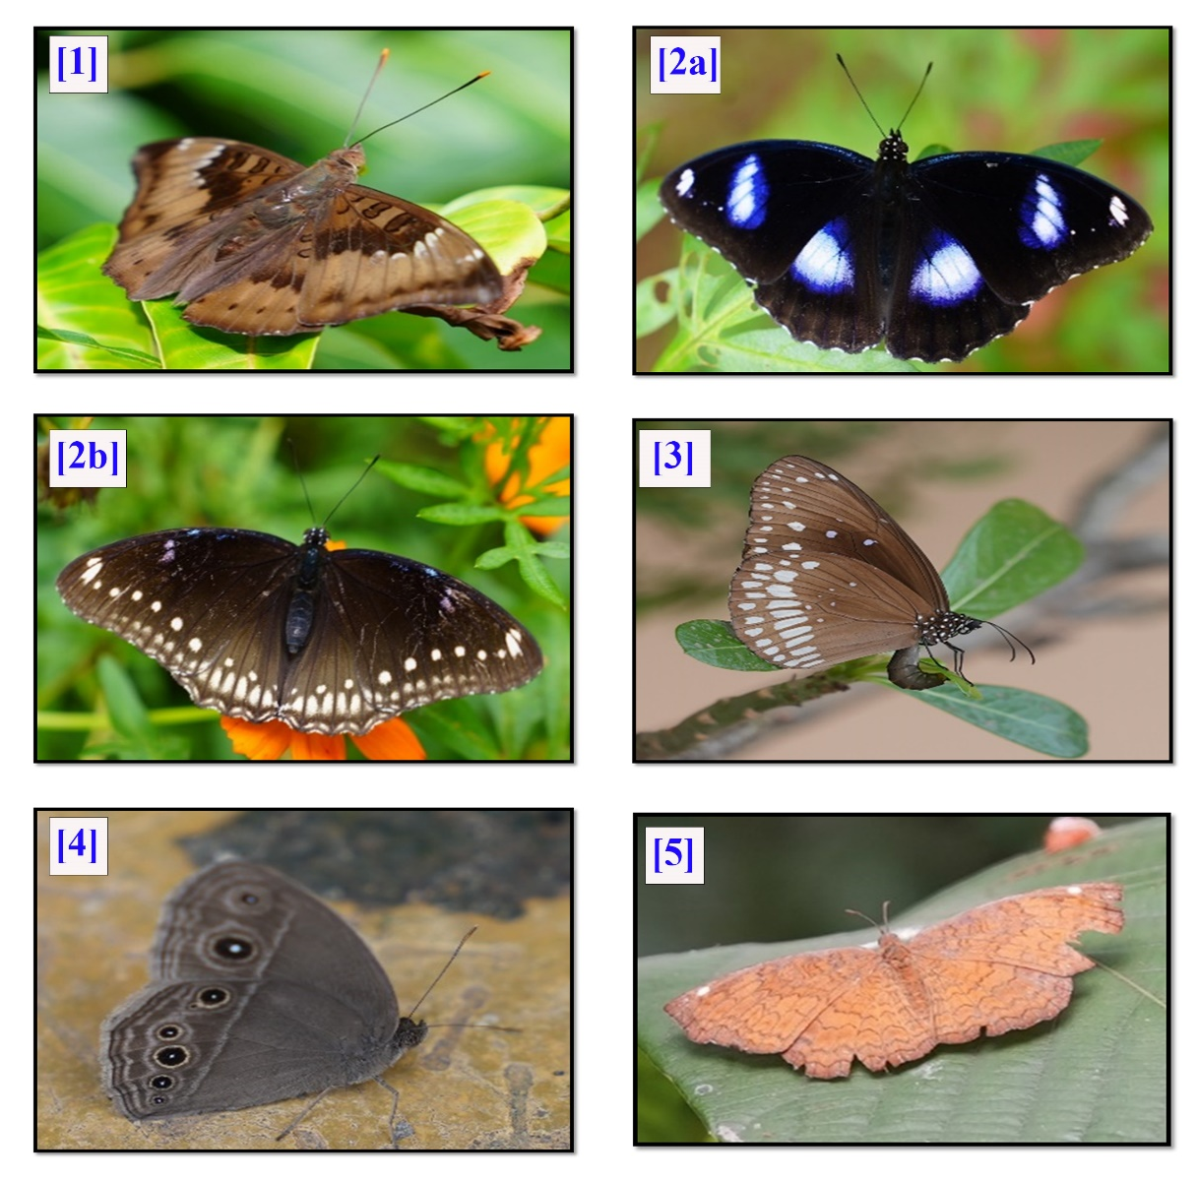
Figure 1: [1] Common Baron (Euthalia aconthea); [2a] Great Eggfly Male (Hypolimnas bolina);
[2b] Great Eggfly female; [3] Common Crow (Euploea core);
[4] Dark Band Bush Brown (Mycalesis mineus); [5] Common Castor (Ariadne merione)
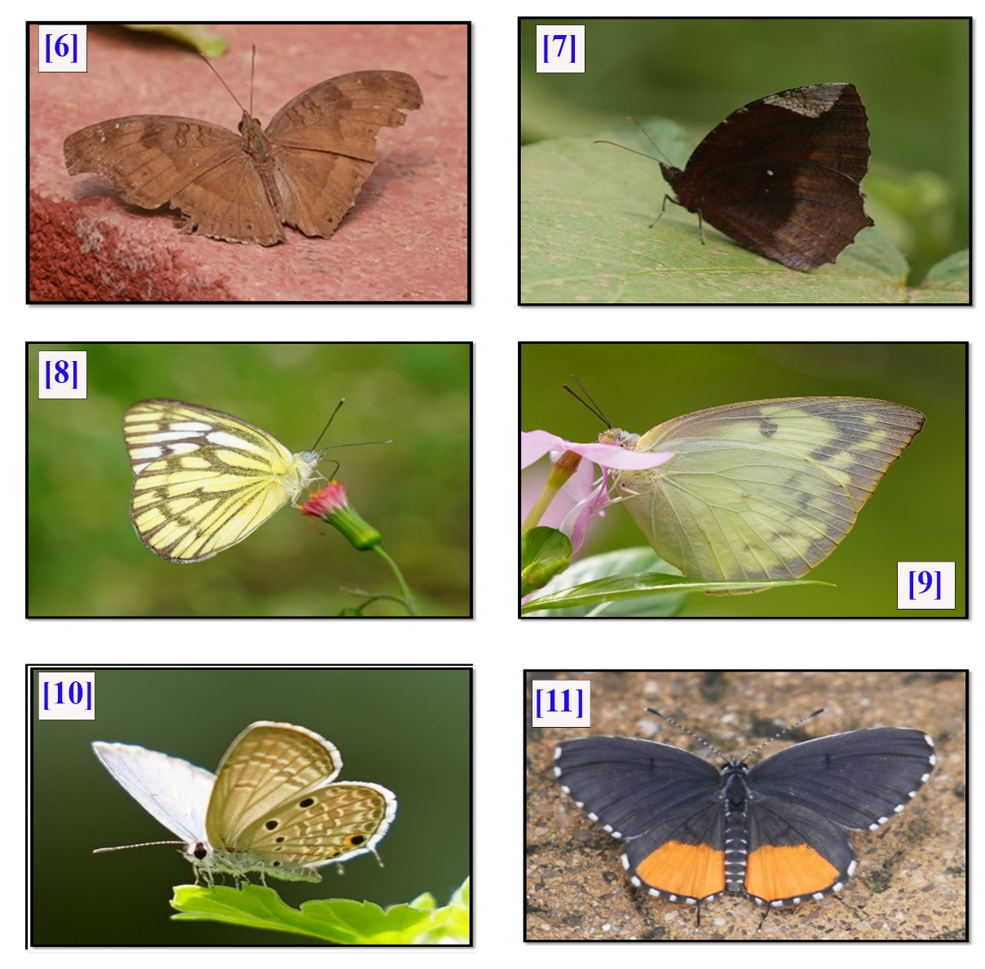
Figure 2: [6] Chocolate Pansy (Junonia iphita); [7] Common Palm Fly (Elymnia hypermnestra);
[8] Common Gull (Cepora nerissa); [9] Lemon Emigrant (Catopsilia pomona);
[10] Plains Cupid (Luthrodes pandava); [11] Red Pierrot (Talicada nyseus);
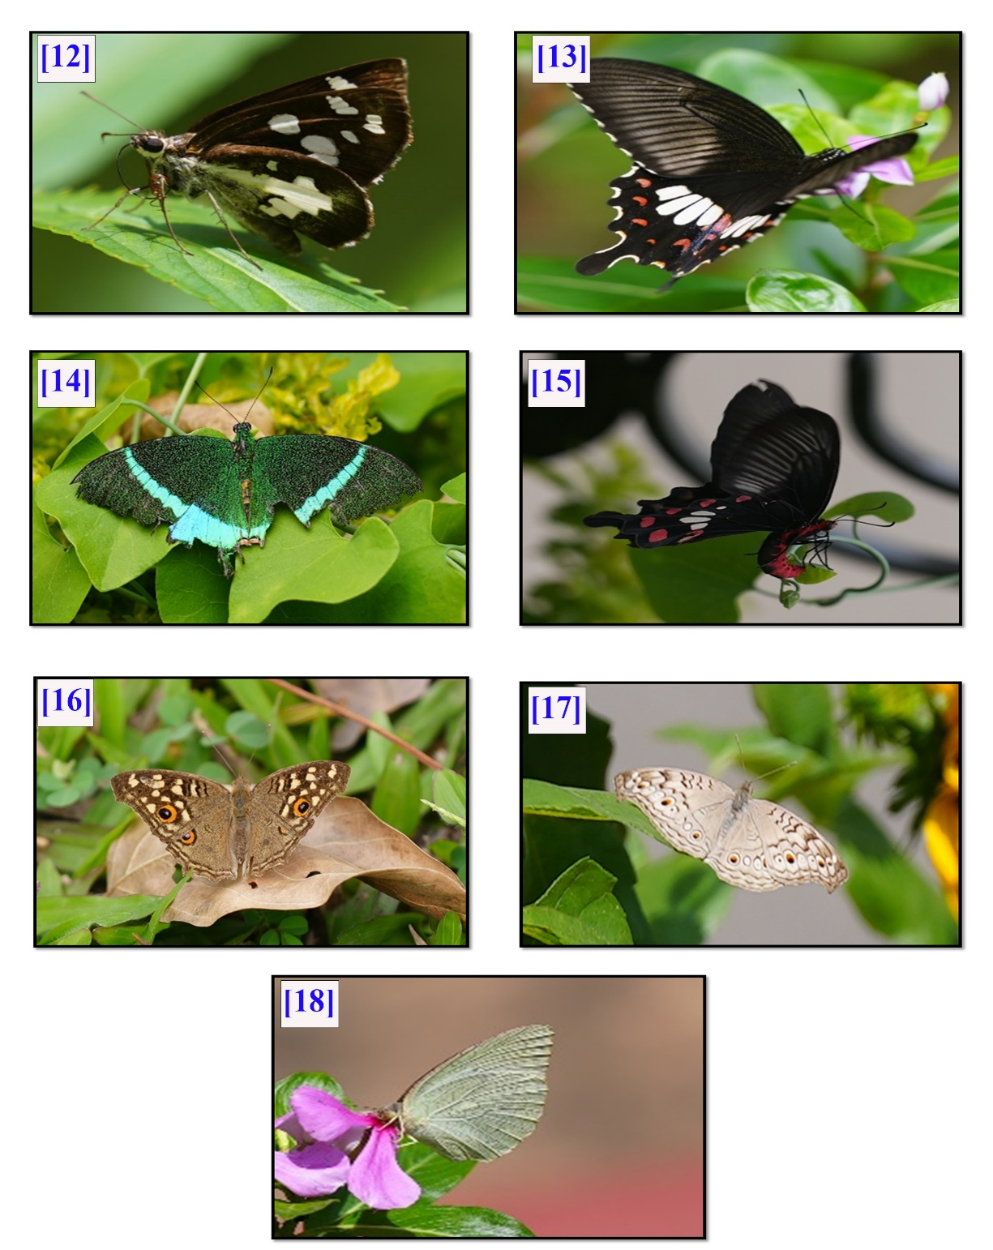
Figure 3: [12] Grass Demon (Udaspes folus); [13] Common Mormon (Papilio polytes);
[14] Common Banded Peacock (Papilio budha); [15] Common Rose (Pachliopta aristolochiae);
[16] Lemon Pansy (Junonia lemonias); [17] Grey Pansy (Junonia atlites);
[18] Mottled Emigrant (Catopsilia pyranthe)

